**Assignment 1 FINAL REPORT**

**Title: Analyzing the Effect of Size on Maintainability in Java Projects**

**Group-7  
 Pranavi Mittapalli**

**Akshith Paspula**

**Section 1 : Introduction**

In this research paper we are going to show the relationship between the size of the java project and the maintainability that is related to them. The main goal of this project is to understand how the number of lines of code in a Java project can affect the maintainability. The research mainly shows the framework of Goal-Question-Metric whose work is to analyze and ensure. Java is an important programming language for the study purpose and its related application that is associated with it which has a wide range of use.The results that are obtained through Java programming can be applied to a wide range of projects and development teams include online applications, mobile apps and corporate systems. The Goal-Question-Metric methodology basically defines the research goals, formulate relevant questions and identify the appropriate metrics for analysis. The primary aim is to examine the relationship between Java project size and maintainability with the software development that can maintain the code.

To assess maintainability there are many metrics that are selected for the investigation. The metrics include the Lines of Code metrics , Coupling Between Objects , Response for a Class and Tight Class Cohesion . The metrics of Coupling Between Objects mainly measures the degree of interdependence between classes. When the maintainability is higher with lower coupling then it indicates that the complexity that is associated with the metrics is on a lower level. Response for a Class is a metric that counts the number of methods that can be executed in response to a message received by a class object. When the RFC value is low then it can have high maintainability. The smaller number of methods to be executed implies a more focused and cohesive class design. Tight Class Cohesion is merices that can evaluate the level of interconnection between methods within a class. When the cohesion is higher then that means it indicates that the maintainability is stronger. The size of Java projects measured in LoC, the study aims to establish the correlation between project size and maintainability. The findings are expected to reveal trends and patterns that can guide the development of best practices for overseeing and sustaining large-scale Java projects.

**Section 2 : Data set Description**

|  |  |  |  |  |  |
| --- | --- | --- | --- | --- | --- |
| **Project Name** | **Repository URL** | **Description** | **Size (LoC)** | **Developers** | **Age (Years)** |
| apollo | https://github.com/apolloconfig/apollo | Apollo is a reliable configuration management system suitable for microservice configuration management scenarios. | 27561 | 143 | 8 |
| ghidra | https://github.com/NationalSecurityAgency/ghidra | Ghidra is a software reverse engineering (SRE) framework | 1697612 | 238 | 4 |
| java-design-patterns | https://github.com/iluwatar/java-design-patterns | Design patterns implemented in Java | 32211 | 347 | 2 |
| mall | https://github.com/macrozheng/mall | The project is an e-commerce system consisting of a front-end mall system and a back-end management system, implemented using SpringBoot+MyBatis and deployed with Docker containers. | 100691 | 1 | 1 |
| spring-framework | https://github.com/spring-projects/spring-framework | Spring Framework | 653907 | 734 | 8 |

**Section 3 : Tool Description**

In this research paper CKJM tool is basically utilized so that for the chosen project C&K mertices can measure the class . CKJM is a software tool that is used to operate with Java-based projects and perform the computation of Chidamber and Kemerer's metrics for object-oriented programming. CKJM is specifically designed to work with Java-based projects and compute the C&K metrics. It includes Coupling Between Objects, Response for a Class and Tight Class Cohesion . The Metrics are directly relevant to the research inquiry and provide insights into the correlation between project size and maintainability. CKJM is a command-line utility that offers a user-friendly interface and easy installation and operation. It accepts Java bytecode files in the .class format and generates the desired metrics in a clear and concise manner. The user's familiarity with the tool allows for efficient acquisition of the required measurements without investing significant time in understanding complex instruments. CKJM is an open-source tool accompanied by a user guide . It also ensures transparency and facilitates users' understanding of its functionality and the metrics it provides. The transparent metrics acquisition process enhances the reliability and trustworthiness of the obtained measurements for analytical purposes. One of the advantages of CKJM is the flexibility that is associated with it as it allows the user to select the specific C&K metrics they wish to compute . It enables the user to choose the relevant metrics for the analysis. For understanding maintainability in Java projects the main thing that needs to focus on is the CBO, RFC and TCC.

The CKJM software metric tool is accessible with the subsequent Uniform Resource Locator : <https://github.com/mauricioaniche/ck>

CKJM is a well-established and widely referenced tool that has been utilized in numerous academic investigations. To utilize CKJM for the analysis the first step involved retrieving the source code of each selected project from the GitHub platform. The projects were then compiled to generate the corresponding Java bytecode files (.class). Second step, the CKJM tool was used to obtain the C&K metrics measurements for each class. These metrics were employed to examine the correlation between project size and maintainability in the designated Java projects. Java being a user-friendly interface, open-source nature, transparency, flexibility in metric selection and established reputation within the research community make it a reliable instrument for this research paper.

**Section 4 : Project Results**

**Project 1: apollo**

|  |  |  |  |  |
| --- | --- | --- | --- | --- |
|  | **CBO** | **RFC** | **TCC** | **LOC** |
| **Max** | 36 | 115 | 1 | 350 |
| **Mode** | 2 | 0 | 1 | 2 |
| **Median** | 6 | 5 | 0.333333 | 26 |
| **Std Deviation** | 6.667597699 | 17.01130632 | 0.607208 | 52.40242657 |
| **Average** | 7.310509554 | 12.16878981 | 0.356834 | 43.88694268 |

**Project 2: ghidra**

|  |  |  |  |  |
| --- | --- | --- | --- | --- |
|  | **CBO** | **RFC** | **TCC** | **LOC** |
| **Max** | 212 | 512 | 1 | 9774 |
| **Mode** | 2 | 0 | 0 | 5 |
| **Median** | 4 | 5 | 0.00952381 | 26 |
| **Std Deviation** | 8.806323764 | 25.26468581 | 0.441375846 | 174.8147493 |
| **Average** | 7.007323027 | 13.46229284 | 0.196278144 | 72.6997559 |

**Project 3 : java-design-patterns**

|  |  |  |  |  |
| --- | --- | --- | --- | --- |
|  | **CBO** | **RFC** | **TCC** | **LOC** |
| **Max** | 19 | 49 | 1 | 496 |
| **Mode** | 2 | 0 | 0 | 5 |
| **Median** | 3 | 3 | 0.06666667 | 12 |
| **Std Deviation** | 2.524117 | 5.971691 | 0.61382639 | 25.11259451 |
| **Average** | 3.23631 | 4.795833 | 0.266046893 | 19.17321429 |

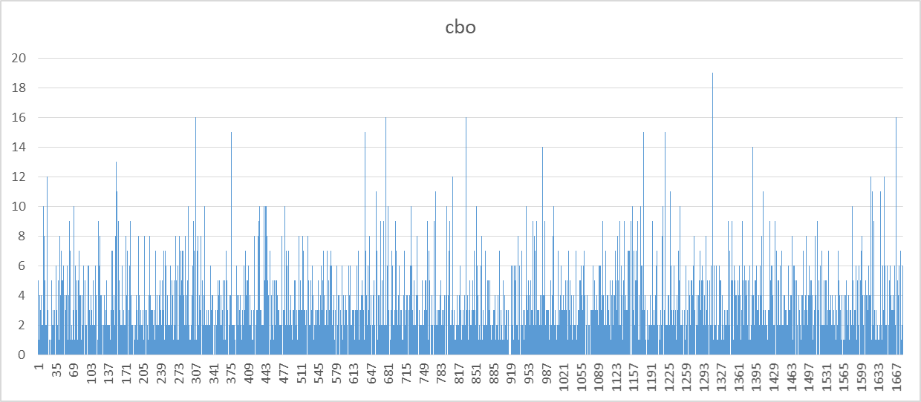

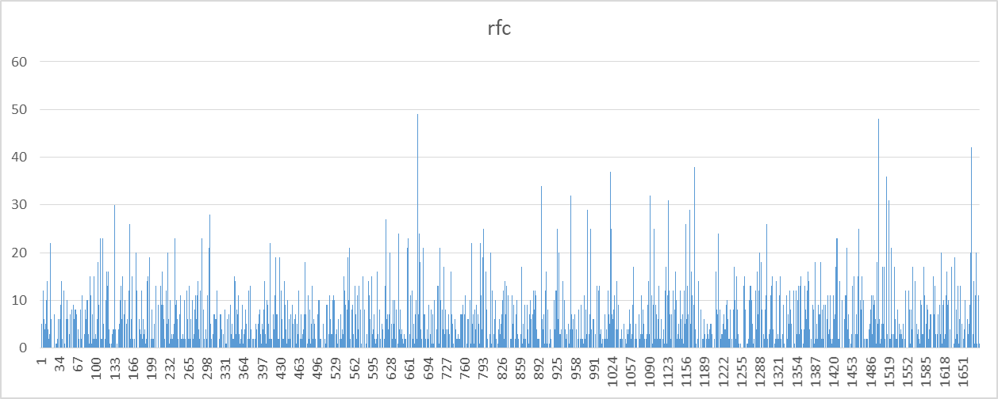

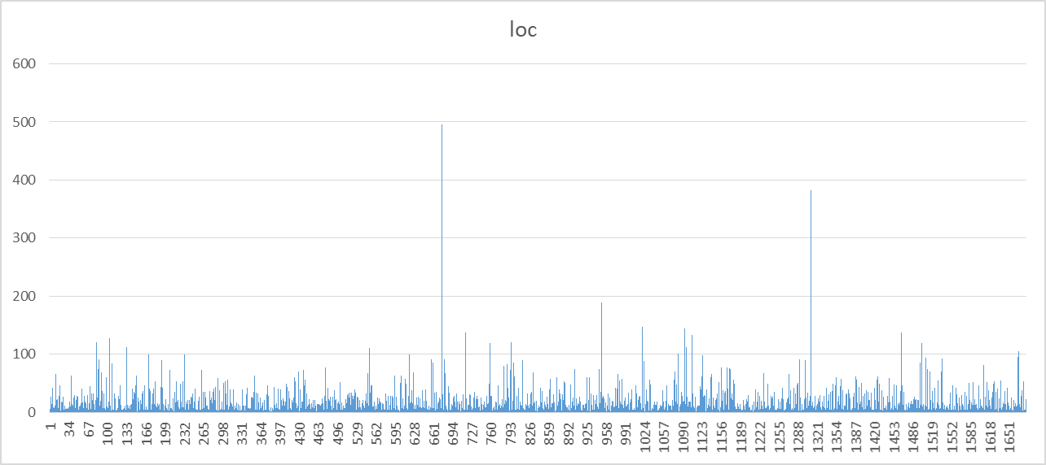

**Project 4: mall**

|  |  |  |  |  |
| --- | --- | --- | --- | --- |
|  | **CBO** | **RFC** | **TCC** | **LOC** |
| **Max** | 45 | 214 | 1 | 2400 |
| **Mode** | 3 | 0 | 0 | 5 |
| **Median** | 3 | 0 | 0.111111 | 32 |
| **Std Deviation** | 4.946221 | 11.64802 | 0.486797 | 261.9813 |
| **Average** | 3.912467 | 4.834218 | 0.146681 | 133.5424 |

**Project 5: spring-framework**

|  |  |  |  |  |
| --- | --- | --- | --- | --- |
|  | **CBO** | **RFC** | **TCC** | **LOC** |
| **Max** | 197 | 270 | 1 | 4800 |
| **Mode** | 1 | 0 | 0 | 2 |
| **Median** | 3 | 2 | 0 | 12 |
| **Std Deviation** | 6.882079 | 15.65635 | 0.619358 | 104.34 |
| **Average** | 5.24215 | 8.257181 | 0.073941 | 41.64747 |

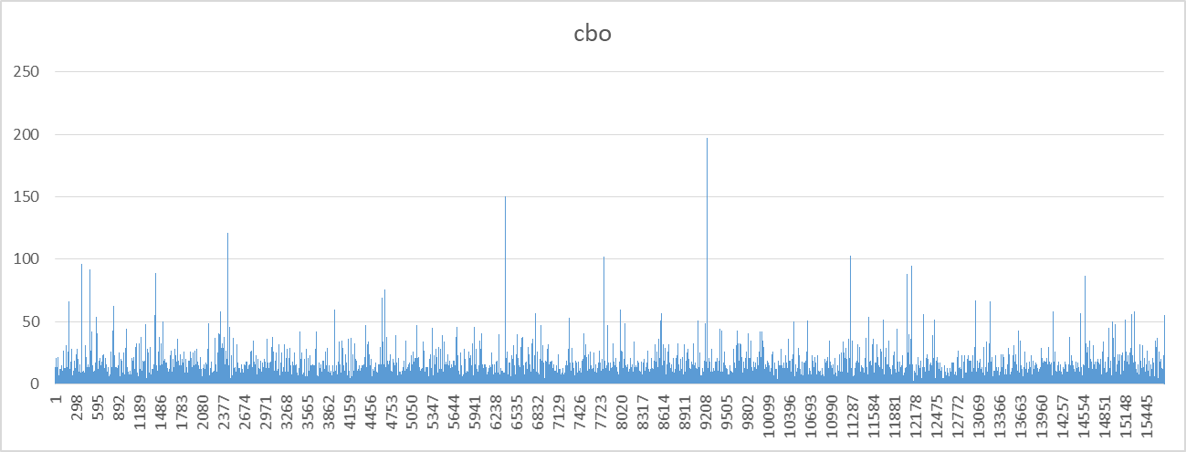

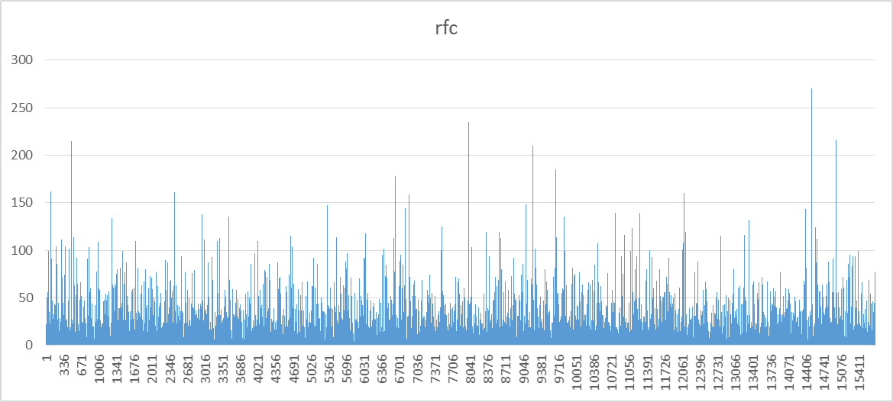

**Section 5 : Conclusion**

The research paper provides valuable information for developers and organizations aiming to improve their software development processes. An analysis of C&K metrics measurements derived from a set of Java projects was conducted to examine the correlation between project size and maintainability. The analysis mainly reveals larger classes that are measured by Lines of Code (LoC) that tend to exhibit greater coupling and increased response for a given class . This also creates a positive relation between the class size and the interconnectivity with the other class as a result the number of methods that can be executed within a class . When the coupling is higher then RFC can create a negative impact in the maintainability. When a single class requires modification then multiple classes are required to change and a large number of methods also can introduce the complexity . The relationship between Tight Class Cohesion and class size is not always observed. The positive relation between class size and cohesion exists while in other cases a negative relation is also observed. This also shows that the relation between the size and cohesion is complex. It is also dependent on the variable like the development methodologies, code structure and field of application.

The effect of size on maintainability also varies across different projects. Some projects demonstrate proficiency in handling maintainability challenges associated with size, while others encounter difficulties in maintaining code quality as the project size expands. This indicates project-specific factors like development methodologies, the proficiency of developers and the complexity of the application domain. It can significantly impact the correlation between size and maintainability in Java projects. Large projects like those with high coupling and high RFC really can pose greater difficulties in maintenance. To address the challenges, developers should employ strategies such as modular design, efficient code organization and adherence to design principles that promote low coupling and high cohesion. This research paper has the potential to explore the impact of development practices, code organization and application domain complexity on maintainability. To gain a deeper understanding of the factors contributing to the observed correlations between size and maintainability in Java projects.

**Reference :**

IntelliJ Platform SDK Documentation. (2023, April 9). GitHub. <https://github.com/JetBrains/intellij-sdk-docs>

Intra. (2023, April 7). GitHub. <https://github.com/Jigsaw-Code/Intra>

Apache/opennlp. (2020, September 9). GitHub. <https://github.com/apache/opennlp>

Netflix/Priam. (2023, March 15). GitHub. <https://github.com/Netflix/Priam>

Achtaich, A., Rowdies, O., Souissi, N., Salinesi, C., & Mazo, R. (2019, September). Evaluation of the state-constraint transition modeling language: A goal question metric approach. In *Proceedings of the 23rd International Systems and Software Product Line Conference-Volume B* (pp. 106-113).

Tuah, N. M., & Wills, G. B. (2020). Measuring the application of anthropomorphic gamification for transitional care; a goal-question-metric approach. In *Computational Science and Technology: 6th ICCST 2019, Kota Kinabalu, Malaysia, 29-30 August 2019* (pp. 553-564). Springer Singapore.

Utomo, R. G., Wills, G., & Walters, R. (2021). Developing an instrument to measure information assurance implementation for eGovernment using goal question metric approach. *Kinetik: Game Technology, Information System, Computer Network, Computing, Electronics, and Control*.